**VIETNAM NATIONAL UNIVERSITY, HO CHI MINH CITY**

**HO CHI MINH CITY UNIVERSITY OF TECHNOLOGY**

**OFFICE FOR INTERNATIONAL STUDY PROGRAMS**

**FACULTY OF TRANSPORTATION**

**Capstone Project**

**Modeling and simulation the resistance torque for specific wheel alignment in the Electric Power Steering system by using Matlab/Simulink and its application.**

**Instructor: Ph.D. Ngô Đắc Việt**

**Ph.D. Trần Đăng Long**

**Class:** CC19OTO1

**Name: Hồ Bình Minh**

**Student ID: 1852169**

May 22th, 2023, Ho Chi Minh City, Vietnam

**🙦 Semester 222**



1. **Student’s name**: Hồ Bình Minh - Student ID: 1852169
2. **Major**: Automotive Engineering - Class: CC19OTO1
3. **Thesis title**: Modeling and simulation the resistance torque for specific wheel alignment in the Electric Power Steering system by using Matlab/Simulink and its application.
4. **Content:**

* Find out how wheel alignment can affect the resistance torque in the steering mechanism especially in the EPS system.
* Fully understanding knowledge about the resistance torque between the tire force and road surface in steering mechanism especially in the EPS system.
* Build the complete model of the resistance torque between the tire forces and road by using Matlab/Simulink.

1. **Result**: Learning how the tire forces and wheel alignment can affect to the steering mechanism through the resistance moment and illustrating its effects which is showed in the result diagram from Matlab/Similunk.
2. **Product**:
   * Presentation report.
   * Poster.
   * Result diagrams
3. **Assigned day**: 23 December 2022.
4. **Finished day**: 22 May 2023.

The content and requirements of the thesis is already approved by the Head of Department of Automotive Engineering.

HCMC, day….... month…… year 2023 HCMC, day… . month…… year 2023

**Head of Department**  **Instructor**

**ACKNOWLEDGEMENT**

First and foremost, I want to express my gratitude to my family, who have always been by my side, accompanying, supporting, and assisting me in any way possible so that I can get to where I am now. I want to thank the teachers at Bach Khoa University in general and the Department of Automotive Engineering for their efforts. The knowledge I have gained from teachers over the last four years has assisted me in being brave enough to complete this project.

Sincere thanks to PhD. Ngo Dac Viet, PhD. Tran Dang Long created conditions for me to study, practice, and conduct field surveys.

Finally, I want to thank the reviewer and department lecturers for sharing their knowledge and providing me with feedback and suggestions so that I could finish this project.

Wishing health to parents, family, lecturers in the Faculty of Transportation Engineering as well as lecturers in the Department of Automotive Engineering and all of my friends in class CC19OTO1.

Best Regards,

Ho Binh Minh

**ABSTRACT**

Vehicle steering dynamics is an essential topic in development of safety driving systems. These complex and integrated control units require precise information about vehicle steering dynamics. In the term of interaction between tire forces and road surface, we are going to primarily focus on the total resistance moment which is the factor torque that urges the tires to steer. This resistance moment that causes this combine with the wheel alignment will be described in below when considering the mass of vehicle, lateral force generation, longitudinal force generation and normal force generation. Through this Capstone project, this torque will be fully showed with the theoretically corresponding equations and combine with the model diagrams by using Matlab/Simulink software.

# TABLE OF CONTENTS

TABLE OF CONTENTS v

TABLE OF FIGURES: vi

LIST OF TABLES vii

**I/ INTRODUCTION:** 1

**1)** **Objective:** 1

**2)** **Scope of implementation:** 2

**3)** **Working condition:** 2

**4)** **Technical requirement:** 2

**5)** **Mission summary:** 2

II/ THEORETICAL BASICS: 3

**2.1)** **General Steering Theory:** 3

2.1.1. Coordinate systems: 3

2.1.2. Model terminology 4

**2.2)** **Steering System Modeling and Wheel Alignment Theory:** 6

2.2.1. Steering system overview: 7

2.2.2. Wheel Alignment: 10

III/ SPECIFIC VEHICLE STEERING EQUATIONS: 12

**3.1) Mathematical modeling of tire force:** 12

**3.2) Mathematical modeling of the resistance torque:** 16

3.2.1. The resistance torque by longitudinal forces: 16

3.2.2. The resistance torque by lateral forces: 19

3.2.3. The resistance torque by normal force: 24

IV/ MATLAB/SIMULINK SOFTWARE: 28

V/ RESULT AND DISCUSSION: 43

VI/ CONCLUSION AND FUTURE PLAN: 57

VII/ REFERENCES: 58

**TABLE OF FIGURES:**

Figure 1: Electric Power Steering system structure 1

Figure 2: Overall scheme of ISO coordinate system for vehicle 4

Figure 3: Vehicle dynamics terminology used in this project 5

Figure 4: Steering systems (rack and pinion) 7

Figure 5: Steering gear schematic 8

Figure 6: A front-wheel-steering vehicle 9

Figure 7: The diagram comparison of the inner and outer angle between the actual condition and the Ackerman condition 9

Figure 8: Overall Caster angle 10

Figure 9: Kingpin angle and its scrub radius 11

Figure 10: A front view of a cambered tire and the generated camber force. 12

Figure 11: Scheme used to calculate the resistant torque generated by FX 17

Figure 12: Tire print deflection and resistance moment with pneumatic trail 19

Figure 13: A positive and negative caster on the front wheel of a car 20

Figure 14: Summary of the effect of the trail during forward movement 21

Figure 15: Scheme used to calculate the resistance torque generated by FY 22

Figure 16: Scheme used to calculate the resistance torque generated by FZ 24

Figure 17: The vehicle speed effect on the total resistance torque 43

Figure 18: The tested model in the article 44

Figure 19: The steering wheel angle effects on the total resistance torque 45

Figure 20: The time responses of the steering angle of the front wheel 46

Figure 21: Vehicle mass effects on the total resistance torque 47

Figure 22: Kingpin angle impact on the total resistance torque 48

Figure 23: Caster angle effects on the steering resistance torque 49

Figure 24: The Camber angle effect on the total resistance torque 50

**LIST OF TABLES**

**Table 1 –** Summary table of the resistant torque acting on the EPS steering system for wheel alignments 27

**Table 2 –** Model Parameters. 43

**I/ INTRODUCTION:**

1. **Objective:**

During the past years, steering mechanisms and its relevant fields have been researched and developed in gradually increasing numbers. The steering system is one of the most important systems in a vehicle, providing the driver with both safety and comfort. One of the factors that greatly affect the steering system is the steering resistance torque, which opposes the driver's steering effort and requires more force to steer. This steering resistance torque comes from the interaction between the tire forces and the road surface, combined with the moment arm created by specific wheel alignment. In an electric power steering (EPS) system, it is necessary to calculate this steering resistance torque to provide the necessary assistance force from the motor during power assist. That is why in this entire project, I will focus on building mathematical models and simulations of the magnitude of this resistance torque under different driving conditions.

Figure 1: Electric Power Steering system structure

1. **Scope of implementation:**

The model is developed to present vehicle behavior when driving in normal conditions of roads and cars, so it can not be reliable in non-linear conditions (When the vehicle is driven up to its limits). The model developed in this project does not represent the steering condition in parking situations. The model is developed by assuming that the wheels are in contact with the road surface. So, the wheel lift phenomenon is assumed negligible in this model. Besides, the resistance moment that acts on the wheel withstands a lot of types of force: longitudinal force, lateral force, and wheel alignment angle: kingpin angle, caster angle, camber angle, etc.

In this project, this resistance torque is going to be fully considered in the effect of tire forces with the specific wheel alignment.

1. **Working condition:**

Continuously change to adapt to variable driving conditions.

1. **Technical requirement:**

Working normally in the above condition.

1. **Mission summary:**

As I mentioned in the scope of implementation, this project is mainly going to focus on the resistance torque under the effect of wheel alignments and other specific factors such as vehicle mass, steering angle, and so on. Based on this scope, I will divide the whole objective into 2 main missions: The first one is to get a fully understanding knowledge about the resistance torque between the tire force and road surface in the steering mechanism especially in the EPS system and the second one is how wheel alignment and other factors can affect to the resistance torque in steering mechanism especially in the EPS system.

# II/ THEORETICAL BASICS:

* 1. **General Steering Theory:**
     1. **Coordinate systems**:

In the following section, the basic concepts of the coordinate systems used in this project will be presented. In this model, the ISO coordinate systems are used. They are based on the seven coordinate systems as following:

* Earth (X, Y, Z)

The global coordinate system describes the entire environment of the model. It is used as the position reference for the vehicle because of the global coordinate system which does not move.

* Vehicle (x, y, z)

The Center of Gravity (COG) coordinate system describes the position of COG during simulation. In this coordinate system, the x-axis is parallel to the longitudinal movement of the vehicle and points to the front of the vehicle. The y-axis is parallel to the lateral movement of the vehicle and the Z-axis is parallel to the vertical movement of the vehicle.

* Wheel (xw, yw, zw)

The wheel coordinate system is in the center of each wheel. In this coordinate system, the x-axis points to the heading of the wheel.

* Path (xp, yp, zp)

The velocity coordinate system is fixed to the center of gravity of the vehicle. The difference in the center of gravity positions follows the velocity vector of the vehicle such as longitudinal velocity (in the x-axis direction), Lateral velocity (in the y-axis direction), and vertical velocity. (in the z-axis direction)

* Yaw (ψ)

Yaw is the rotation around the vertical axis (z-axis) through the center of gravity of the vehicle. The yaw can be felt in skidding or spin movement.

* Pitch (φ)

Pitch is the rotation around the lateral axis (y-axis) through the center of gravity of the vehicle. It can be felt in acceleration or braking movement around the y-axis of the vehicle.

* Roll (ϴ)

Roll is the rotation around the longitudinal axis (x-axis) through the center of gravity of the vehicle. This rotation can be felt during lateral acceleration (side-to-side movement) of the vehicle.

The overall scheme of the ISO coordinate system is shown in Figure 2.

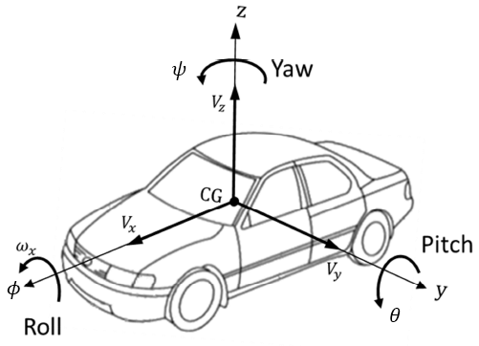

Figure 2: Overall scheme of ISO coordinate system for vehicle

* + 1. **Model terminology**

In this part, vehicle dynamics terminology used in this project is shown in Figure 3 and described respectively:

*Negative Caster*

*Positive Caster*

Figure 3: Vehicle dynamics terminology used in this project

As we can see in Figure 3, the tire is the main component interacting with the road. The performance of a vehicle is mainly influenced by the characteristics of its tires. Tires affect a vehicle’s handling, traction, ride comfort, and fuel consumption. To understand its importance, it is enough to remember that a vehicle can maneuver only by longitudinal, vertical, and lateral force systems generated under the tires. The steering process mainly depends on the interaction between below forces, moment, and angles:

* Normal force $F_{z}:$ it is a vertical force, normal to the ground plane. The resultant normal force $F_{z}$ > 0 if it is upward. The normal force is also called the vertical force or wheel load.
* Longitudinal force $F_{x}$: It is a force acting along the x-axis. The resultant longitudinal force $F_{x}$ > 0 if the car is accelerating, and $F_{x}$ < 0 if the car is braking. Longitudinal force is also called forward force.
* Lateral force $F_{y}:$ It is a force, tangent to the ground and orthogonal to both $F_{x}$ and $F_{z}$. The resultant lateral force $F_{y}$ > 0 if it is in the y direction.
* Yaw moment $M_{z}$ It is an upward moment about the z-axis. The resultant yaw moment Mz > 0 if it tends to turn the tire about the z-axis. The yaw moment is also called the *aligning moment, self-aligning moment, or more torque*.
* Side-slip angle $α$ is the angle between the velocity vector *v* and the *x*-axis measured about the z-axis. This angle has a big influence on the steering because it directly affects the magnitude of the lateral force $F_{y}$
* Caster angle $τ$ is the angle to which the steering pivot axis is tilted forward or rearward from vertical, as viewed in Figure 3. This is one of the most important factors that affect the resistance torque $M_{z}$.
* Kingpin angle $γ$ is the angle between the kingpin axis and the vertical axis  
  of the tire. The kingpin axis is the line between the lower and upper ball joints of the wheel’s hub.
  1. **Steering System Modeling and Wheel Alignment Theory:**

In this part, the steering system used in this thesis is described. As mentioned before, steering system modeling is one of the most important issues in driving simulation. The high fidelity of steering system simulation is useful to achieve a high reality steering feel for the driver during driving simulation. The steering system modeled during this project consists of two main parts: steering geometry and steering wheel feedback torque. Steering geometry is created to transmit the steering wheel angle applied by the driver as an input to virtual wheels angles as output. Steering wheel feedback torque has the main purpose of transmitting the torque created in a tire (self-aligning torque, friction torque…) to the steering wheel. In other words, the steering system model receives the steering wheel position which is applied by the driver as input and provides the steering wheel feedback torque as output. Besides, wheel alignment angles that are necessary for only this project will also be mentioned in this part.

* + 1. **Steering system overview:**

The steering system transfers the steering wheel angle to the wheels through a mechanical system composed of a series of rods and pivot linkages. In this case, when the driver turns the steering wheel, the steering wheel’s rotation is transmitted through the steering column (steering shaft) to the pinion, and the pinion converts the rotation to the linear displacement through the rack and pinion. The created linear movement is transferred to the uprights through the tie roads. The created linear movement upright generates the steering angle in the wheels. The steering mechanism between the steering box and the steering angle in the wheels presents a transmission rate which is called steering ratio. It is important to notice that the steering wheel angle and wheel angle relates via a steering ratio coefficient. Rack and pinion steering system is commonly used in conventional cars. In this project, the power steering assistance system is used as well as the rack and pinion system. A power steering assist system helps drivers by decreasing the driver’s effort in the steering wheel. The power steering assistance system is comprised of a DC motor and a control unit so that the control unit calculates if steering assistance is required for the driver. The rack and pinion steering system is shown in Figure 4 and the steering box is shown in Figure 5 respectively.

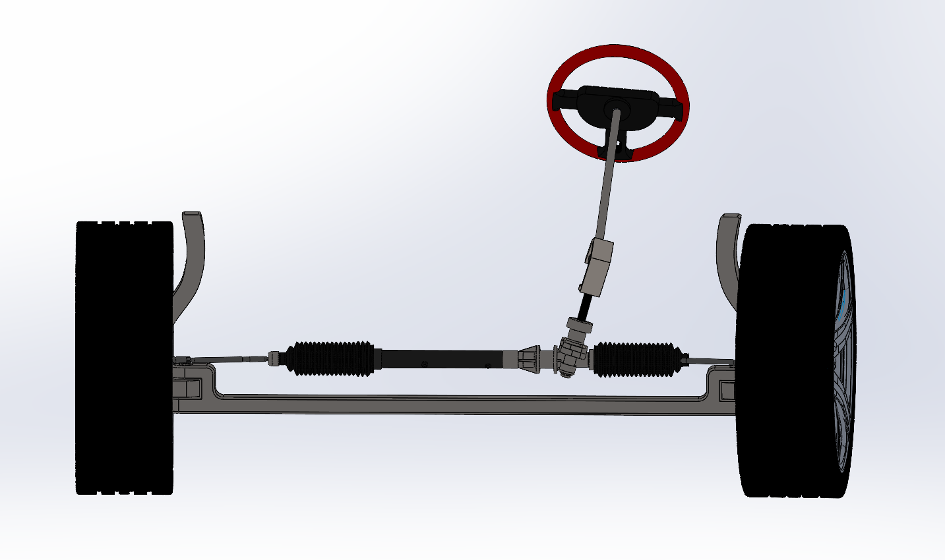

Figure 4: Steering systems (rack and pinion)

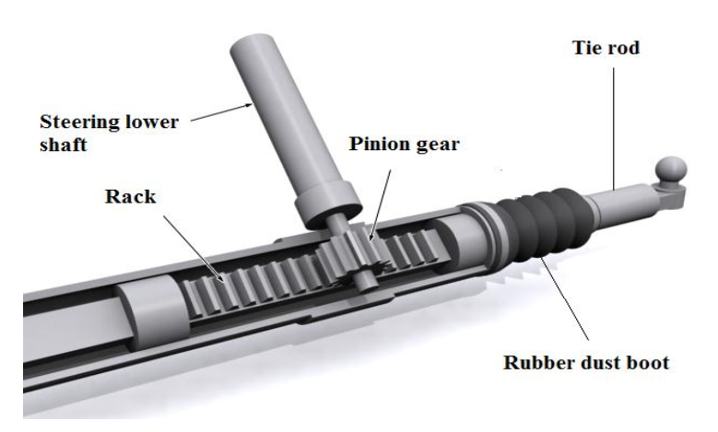

Figure 5: Steering gear schematic

This mechanical linkage between the steering box and the wheels usually conforms to the required condition. When the vehicle is moving very slowly, there is a kinematic condition between the inner and outer wheels that allows them to turn slip-free. It is called as Ackerman condition and is expressed by:

$cotδ_{o}-cotδ_{i}=\frac{w}{l}$

where $δ_{i}$ is the steering angle of the inner wheel, $δ_{o}$ is the steer angle of the outer wheel, The distance between the steer axes of the steerable wheels is called the track and is shown by $w$. The distance between the front and rear axles is called the wheelbase and is shown by $l$. Track w and wheelbase $l$ are considered as the kinematic width and length of the vehicle. Ackerman steering geometry is the term used to describe the behavior of the front wheel when the vehicle is driven around a corner. In the corner when the front tires turn, the inner wheels radius is smaller than the outer wheels and that means the steering wheel is needed to generate the wheel angle for the inner wheels which are larger than the outer wheels, otherwise, the inner wheel tends to slide over the road. The Ackerman geometry neglects the effect of the road on the tire, so it is not completely suitable for modern cars. The wheel's behavior interface corner turning can be seen in Figure 6.

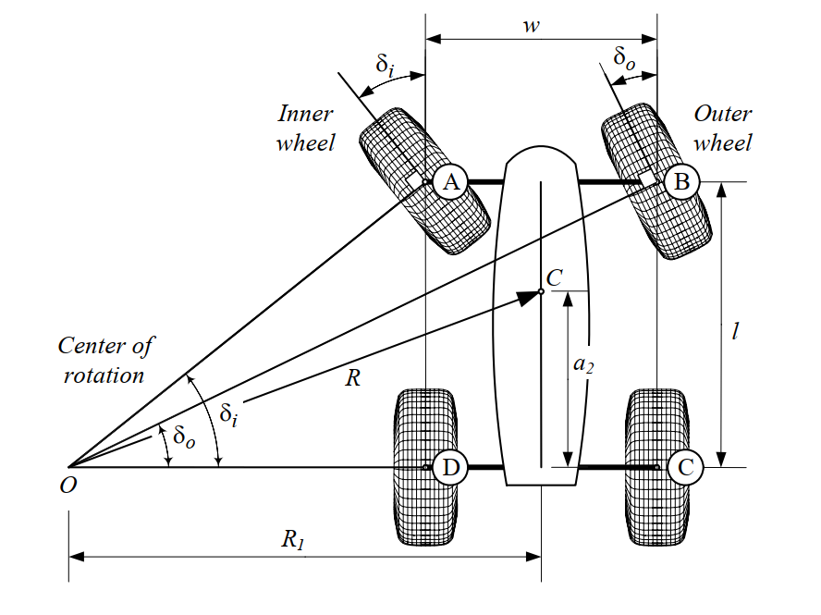

Figure 6: A front-wheel-steering vehicle

As can be seen in Figure 6, the inner wheel angle is larger than the outer wheel, when the vehicle turns around a circle:

$$δ_{i}>δ_{O}$$

It is important to notice that the wheel's behavior analysis is a very important point to accurately simulate tire forces. For this reason, all the parameters which can affect the tires must consider in tire modeling.

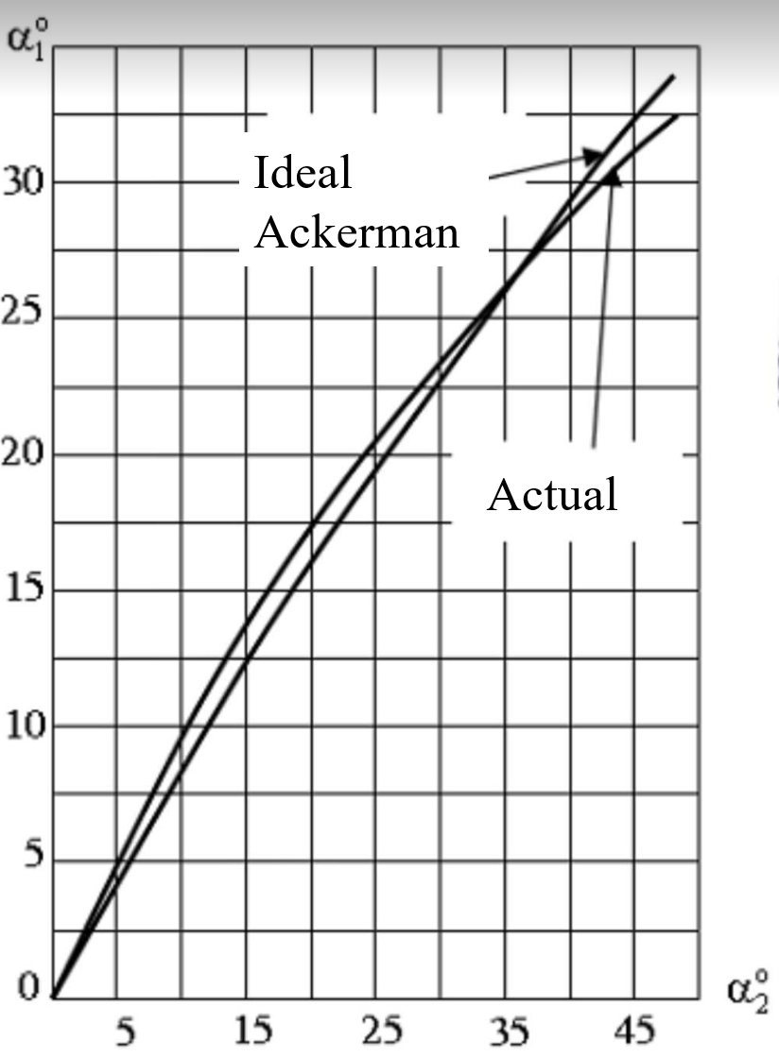

Figure 7: The diagram comparison of the inner and outer angle between the actual condition and the Ackerman condition

From Figure 7, we can see that the ideal Ackerman condition and actual inner and outer steering angle have the minimum error only in the range from 0 to 35 degrees. That is the reason why in this project, the steering angle of the wheel is just under 35 degrees.

### 2.2.2 Wheel Alignment:

**The Caster angle** affects the steering feel by creating a self-centering torque to reduce the toughness of the steering. For example, when the caster angle is positive and the wheel is steered, the lateral forces will create a torque around the steering axis and will increase the self-aligning torque of the tire. Increasing self-aligning torque causes the steering wheel to align quickly. Furthermore, a positive Caster improves the stability of the vehicle in a turn and reduces the under-steering situation of the vehicle when the vehicle is exiting from a turn. A positive caster angle will increase the handling of the vehicle when the vehicle is turning but it causes the steering wheel to be tougher to move. When the caster angle is negative the lateral forces will produce a torque that helps steering. (Figure 8)

*Negative Caster*

*Positive Caster*

Figure 8: Overall Caster angle

**Kingpin angle** has the effects which is usually discussed in terms of the scrub radius offset which determines the value of the self-aligning torque when the wheels are turned. For the zero-scrub radius, no reaction will transmit to the steering wheel and the driver is not able to perceive the change of the vehicle lateral offset. In the case of the positive scrub radius (many conventional cars have a positive scrub radius offset) the wheels are returned to the straight position quickly. In the case of the negative scrub radius (some modern cars have a negative scrub radius offset) the longitudinal forces will generate a moment that increases the steering of the wheels in a longitudinal direction. For this reason, the vehicle becomes more oversteering when the scrub radius offset is negative, thus the driver is not able to sense the self-aligning torque effect correctly. (Figure 9)

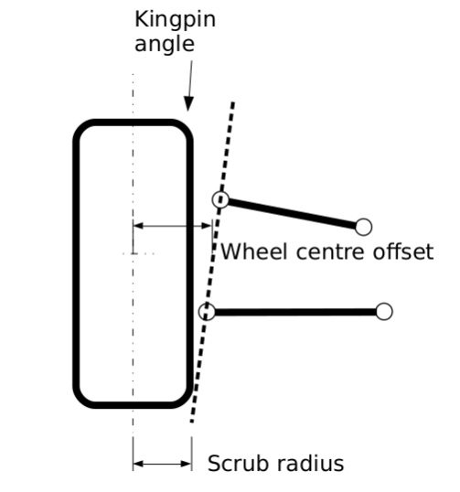

Figure 9: Kingpin angle and its scrub radius

**Camber angle** is the tilting angle of the tire about the longitudinal x-axis. Figure 10 illustrates a front view of a cambered tire and generated camber force $F_{y}$. Camber angle is assumed positive γ > 0, when it is in the positive direction of the x-axis, measured from the z-axis to the tire. A positive camber angle generates a camber force along the y-axis. Itis directly influences the magnitude of the lateral force which the most important factor in a vehicle’s steering.

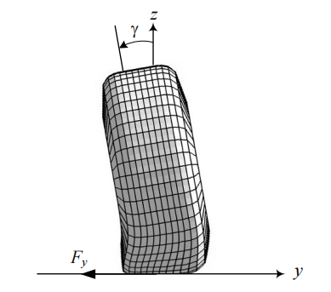

Figure 10: : A front view of a cambered tire and the generated camber force.

In this project, only the Kingpin angle, Caster angle, and Camber angle will be considered for the resistance moment which is going to be mentioned in the next part.

**III/ SPECIFIC VEHICLE STEERING EQUATIONS:**

**3.1) Mathematical modeling of tire force:**

* **Normal force $F_{z}$:** has an influence on a lateral displacement between the contact point of the point of application of this force and the center plane of the wheel. In this project, the driving situation is the vehicle speed is constant which means we have no acceleration for the normal force calculation. The Electric Power Steering system in this project is set up for front-wheel drive, so the equation of front tire is:

${ F}_{z}=m.g.\frac{a_{2}}{l}$**(1)**

While:

$F_{z}$: the normal force (N)

m: mass of the vehicle (kg)

g = 9.8: gravitational acceleration (m/ $s^{2})$

$a_{2}:$ the distance from the center of vehicle mass to the rear axle respectively (m)

* **Lateral force $F_{y}$** : when a turning tire is under a vertical force $F_{z}$ and a lateral force $F_{y}$, its path of motion makes an angle α for the tire plane. Basically, this force is the friction force to the centrifugal force. The angle is called the side-slip angle and is proportional to the lateral force:

$F_{α}=-C_{α}.α_{f}$**(2)**

While:

$F_{α}:$ Sideslip force (N)

$C_{α}$: Cornering stiffness of the tire (N/rad)

$α_{f}:$ side-slip angle (rad or degree)

Camber angle $ε$ is the tilting angle of the tire about the longitudinal x-axis. Camber angle generates a lateral force Fy called camber trust or camber force. This force will be calculated by the equation:

$${ F}_{ε}=-C_{ε}.ε (3)$$

While:

$F_{ε}:$ Camber force (N)

$C_{ε}$: Camber stiffness of the tire (N/rad)

$ε:$ Camber angle (rad or degree)

And the total lateral force will be calculated as:

Fy = $C_{ε}$. $ε$ + Cα. $α_{f}$**(4)**

In terms of lateral force calculation, I will use the longitudinal velocity, lateral velocity, and yaw rate which are taken from this block to calculate the sideslip angle at the center of gravity of the vehicle as the equation (10) below:

$β= \frac{v}{u}$**(5)**

Where:

$β:$ sideslip angle at the center of the vehicle (rad)

$v :$ lateral velocity at the center of the vehicle (m/s)

$u :$ longitudinal velocity at the center of the vehicle (m/s)

After that, I will use the sideslip at the center of gravity to calculate the front sideslip angle of each tire by using the below equation:

$α_{f}= -\left(δ-ξ\right)=β+\frac{aw_{r}}{u}-δ$**(6)**

Where:

δ: front wheel steer angle (rad)

ξ: is the angle between the X-axis and the velocity at the midpoint of the front shaft (rad).

β: sideslip angle at the center of gravity of the vehicle (rad)

$a$: is the distance from the front tire to the vehicle’s center of mass (m).

$w_{r}$: yaw rate of the vehicle’s center of mass (rad/s).

$u$: longitudinal velocity of the vehicle at the center of mass (m/s).

At the maximum lateral force, the wheel will start sliding laterally and its value will be calculated by:

$F_{y}=μ_{y}.F_{z}$**(7)**

While:

$F_{y}:$ Lateral force (N)

$F_{z}$: Normal force at the contact point of the tire and the road surface (N)

$μ_{y}$: Lateral friction coefficient

The slip angle α always increases by increasing the lateral force $F_{y}$. However, the sliding line moves toward the tail at first and then moves forward by increasing the lateral force $F_{y}$. Slip angle α and lateral force $F_{y}$ work as action and reaction. A lateral force generates a slip angle, and a slip angle generates a lateral force. Hence, we can steer the tires of a car to make a slip angle and produce a lateral force to turn the car. In this project, the lateral force is only considered by the effects of the sideslip angle and cornering stiffness of the tire.

* **The rolling resistance force:** In vehicle dynamics, rolling resistance force refers to the force that opposes the motion of a vehicle's wheels as they roll on the road surface. This force is caused by the deformation of the tire and the road surface, as well as other factors such as tire design, inflation pressure, and load. The rolling resistance force is calculated by the equation:

$F_{rolling}= f . F_{z}$**(8)**

While:

$F_{z}:$ Normal force (N)

$f$ = 0.011: rolling resistance coefficient

$F_{rolling}:$ Rolling resistance force (N)

* **Longitudinal force $F_{x}$** : The longitudinal forces are generated between tire and road, due to the difference in velocity between road and tire, when accelerating and braking. The force $F_{x}$ is proportional to the normal force:

$F_{x}=μ_{x}{.F}_{z}$**(9)**

While:

$F_{x}:$ Longitudinal force (N)

$F_{z}$: Normal force at the contact point of the tire and the road surface (N)

$μ_{x}$: Longitudinal friction coefficient.

One of the most important factors that affect the magnitude of the longitudinal force is the longitudinal slip ratio $s$. This slip ratio illustrates the difference between the rotational speed of the tire and the vehicle's longitudinal speed. The slip rate can be calculated as follows:

$$s=\left\{\begin{aligned}\frac{v-R.w}{v} for braking( R.w<v) \\ \frac{R.w-v}{R.w}for acceleration( R.w>v)\end{aligned}\right.$$

While:

$w:$ the rotational speed of the tire (rpm)

$R:$ radius of the tire (inch)

$v:$ vehicle speed (m/s)

**3.2) Mathematical modeling of the resistance torque:**

In the modeling of the steering wheel feedback torque, the resistance moment will be considered from the three forces of forces and wheel alignment. They are described as follows:

### 3.2.1. The resistance torque by longitudinal forces:

These forces create torque in the tire when the vehicle accelerates or brakes. The created torque in the tire due to a longitudinal force is the product of the longitudinal forces and the moment arm. The moment arm in this case is the scrub radius caused by the longitudinal forces effect, which would be sensed in the steering wheel. The total moment generated around the steering axis by $F_{X}$ can be calculated starting from Figure 12:

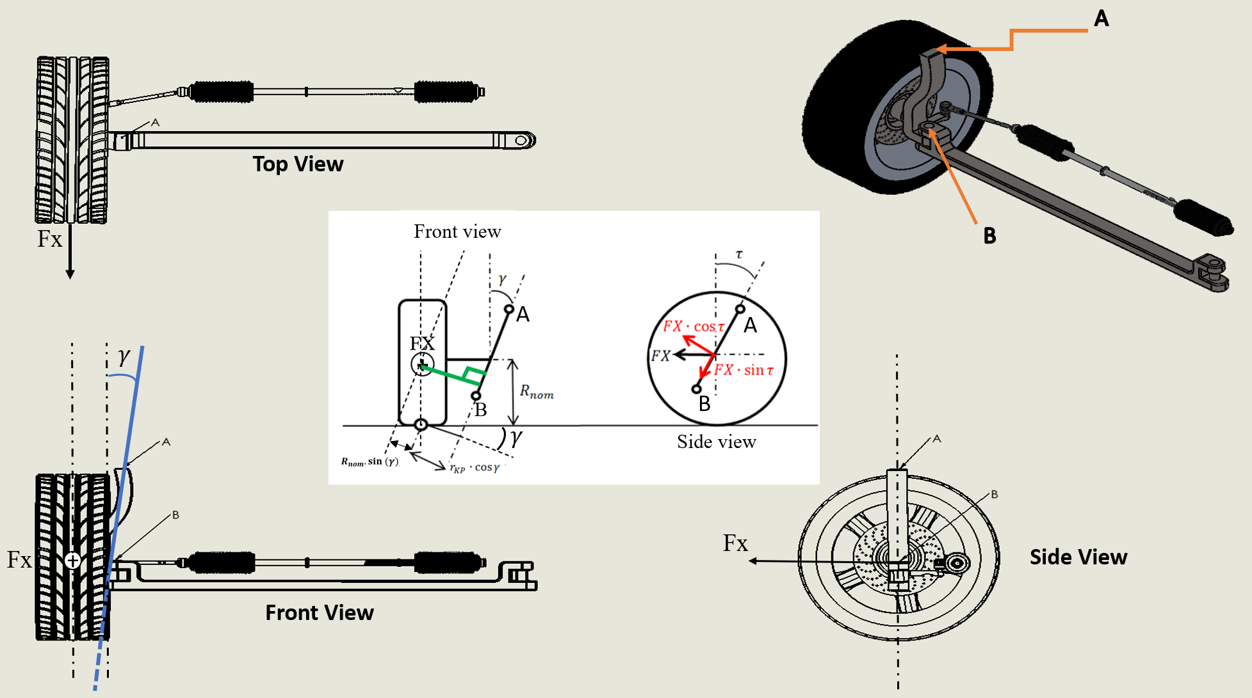

Figure 11: Scheme used to calculate the resistant torque generated by FX

* **Calculation diagram**:

Figure 12 and the above diagram show the total resistance moment generated around the steering axis due to FX with the inputs are vehicle mass, wheel alignment and it can be computed from the:

$M_{zX}=F_{X}.\cos\left(τ\right)\left[r_{kp}.\cos\left(γ\right)+R_{nom}.\sin\left(γ\right)\right]$**(10)**

While:

$M_{z}:$ The resistance torque caused by longitudinal force $F_{x}$ (N.m)

$F_{X}:$ Longitudinal force (N)

$τ:$ Caster angle (degree or rad)

$γ:$ Kingpin angle (degree or rad)

$r_{kp}:$ normal scrub radius of the Kingpin angle (m)

$R_{nom}:$ tire radius (m)

### 3.2.2. The resistance torque by lateral forces:

* **Only Caster angle:**
* Self-resistance moment in the case of pneumatic trail:

Figure 12: Tire print deflection and resistance moment with pneumatic trail

Figure 12 shows that a pneumatic trail is a measure of how a tire's footprint or contact patch changes as it rolls. The pneumatic trail is caused by the progressive build-up of lateral force along the length of the contact patch, such that lateral forces are greater towards the rear of the contact patch (though less so when the rear of the contact patch begins sliding).

A pneumatic trail explains how tires can help you keep your stability and control while you drive. This effect occurs regardless of the steered direction of the tires and can result in a surf-like sensation that occurs when traveling at higher speeds. In the Pneumatic trail input, there is the longitudinal force signal, sideslip signal, and Cornering stiffness signal. From those inputs, we can calculate the pneumatic trail of the left and the right wheelbase on the below equation:

$$t_{p}=t_{p0}(1-sgn\left(α_{f}\right)\frac{C_{α_{f}}}{3.μ_{s}.F_{z_{f}}}.\tan\left(α_{f}\right) (11)$$

Where:

$t_{p}:$ Pneumatic trail (m)

${ t}_{p0}:$ Pneumatic trail at zero slip angle ($t_{p0}=0.03$ m)

$α_{f}:$ Front sideslip angle (rad)

$C_{α}:$ Cornering Stiffness (N/rad)

$μ_{s}:$ Longitudinal frictionn coefficient = 0.35

This force develops and is applied to the length of the contact patch with the rear of the contact patch experiencing the greatest pressure force. This lateral force causes the tire to rotate somewhat, which results in physical force known as a self-resistance moment.

$M_{zp}=F_{y}.$ $t_{p}$**(12)**

While:

$M_{zp}$: The resistance moment caused by pneumatic trail (N.m)

$F_{y} :$ Resultant lateral force (N)

$t_{p}:$ Pneumatic trail (m)

* Self-resistance moment in the case of mechanical trail:

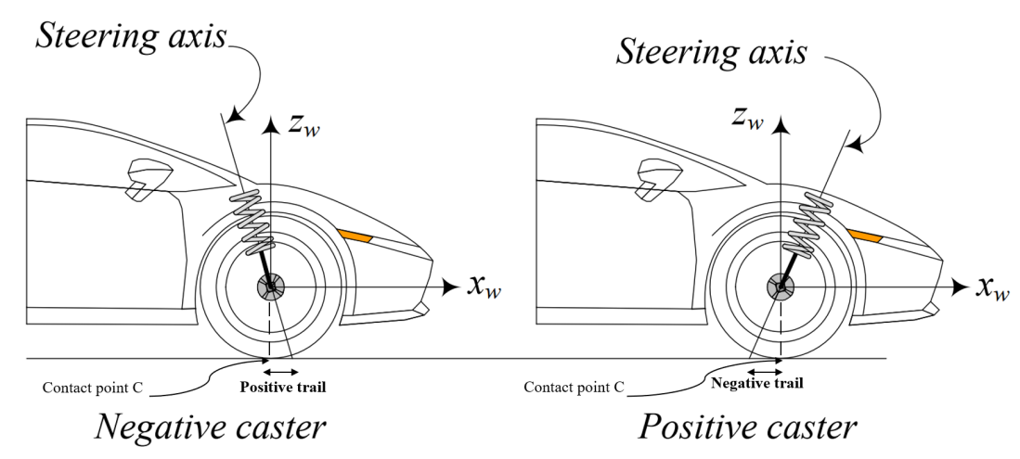

*Positive Caster*

*Negative Caster*

Figure 13: A positive and negative caster on the front wheel of a car

The mechanical trail is the horizontal distance between the point where the steering axis of the front wheel intersects the ground and the point where the front tire contacts the ground which is shown in Figure 13. In this sense, the contact patch of the tire “trails” behind the steering axis. The greater this distance, the “higher” the trail, and the lower the distance the “lower” the trail. This factor also decides how much the Caster angle can affect the steering feeling and how returnability of the vehicle through the resistance moment

$M_{zm}=$ $F_{y}.t_{m}$**(13)**

While:

$M_{zm}:$ The resistance moment caused by mechanical trail (N.m)

$F_{y}:$ Lateral force (N)

$t_{m}:$ Mechanical trail (m)

And the mechanical trail can be be calculated by the following equation:

$${ t}_{m}=\sin\left(τ\right).r_{nom } (14)$$

Where:

$t_{m}:$ Mechanical trail (m)

$r_{nom}:$ Tire radius (m)

$τ:$ Caster angle (rad)

As we can see in Figure 14, since the trail is positive, friction force F generates a moment that tends to align the front wheel. The straightening moment is proportional to the value of the normal trail. Small positive trail values generate small aligning moments of the lateral friction force. A higher value of the trail (obtained with a high value of the caster angle). If the value of the trail were negative (the contact point in front of the intersection point of the steering head axis with the road plane) and considering that friction force F is always in the opposite direction of the velocity of slippage, a moment around the steering head axis that would tend to increase the rotation to the left would be generated

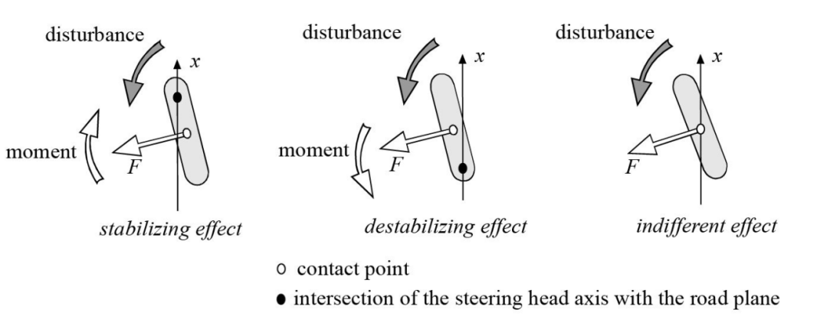

Figure 14: Summary of the effect of the trail during forward movement

* A self-resistance moment in the collaboration of both trails

This moment tends to turn the tire about the z-axis and make the x-axis align with the velocity vector v. The resistance torque always tends to reduce α. It is calculated by the equation:

$M_{z}=M_{zp}+M_{zm}=F_{y} {.(t}_{m}+t_{p})$**(13)**

While:

$M_{z}:$ The resistance torque (N.m)

$M_{zp}:$ The resistance torque caused by pneumatic trail (N.m)

$M_{zm}:$ The resistance torque caused by mechanical trail (N.m)

$F_{y}:$ Lateral force (N)

$t_{p}:$ Pneumatic trail (m)

$t_{m}:$ Mechanical trail (m)

As we can see in the above equation, the self-aligning torque depends on the lateral force and the magnitude of the total trail (the sum of the mechanical and pneumatic trail).

* **Kingpin and Caster angle collaboration:**

Figure 15: Scheme used to calculate the resistance torque generated by FY

* **Calculation diagram:**

Figure 15 and the diagram show the Caster, KPI, and sideslip angle effect on the lateral forces of the tire. So, the generated the torque due to them around the steering axis can be determined from:

$M_{zY}=F_{Y}.\cos\left(γ\right)\left[t.cos\left(τ\right)+R_{nom}.\sin\left(τ\right)\right]$**(8)**

Where:

$M_{zY}:$ The resistance torque caused by lateral force $F_{Y}$ (N.m)

$F_{Y}:$ Lateral force (N)

$τ:$ Caster angle (degree)

$γ:$ Kingpin angle (degree)

$R_{nom}:$ tire radius (m)

### 3.2.3. The resistance torque by normal force:

The resistance torque caused by the normal force $F_{z}$ is one of three resistance components that oppose the steering effort of the driver. In this torque section, the main force affect to the aligning moment is the normal force which is calculated by the equation (1). The force and the moment arm will be illustrated in Figure 16 below:

Figure 16: Scheme used to calculate the resistance torque generated by FZ

* **Calculation diagram:**

Figure 16` and the diagram show how the Caster angle, Kingpin angle, and wheel steering angle can influence the resistance torque caused by the normal force $F_{Z}$ and this torque can be calculated by the equation:

$M_{zZ}= F_{z}.sin\left(γ\right).\cos\left(τ\right).\sin\left(δ\right).\{\cos\left(γ\right).[r_{kp}+R_{nom}.tan⁡(γ)]$**(9)**

Where:

$M_{zZ}:$ The resistance moment caused by lateral force $F_{Z}$ (N.m)

$F_{z}:$ Normal force (N)

$τ:$ Caster angle (degree)

$γ:$ Kingpin angle (degree)

$R_{nom}:$ tire radius (m)

$δ$: Wheel steering angle (degree)

$r_{kp}$: Scrub radius (m)

From the 3.2.1, 3.2.2, 3.2.3 sections, the total resistance torque generated around the steering axis by longitudinal force, lateral force, and normal force can be calculated as:

**Table 1 –** Summary table of the resistance torque acting on the EPS steering system for wheel alignment

|  |  |  |  |  |
| --- | --- | --- | --- | --- |
|  | Caster angle | Camber angle | Kingpin angle | The equation for the resistant torque |
| Longitudinal forces | X | X | X | $M_{resistFX}= F_{X}.cos⁡(τ)[r_{kp}.\cos\left(γ\right)+R_{nom}.sin⁡(γ)$]  While: $F_{X}={(F}_{x}-F_{rolling)}.\cos\left(δ_{i}\right)-F_{y}.sin⁡(δ_{i})$ *“DESIGN OF STEERING WHEEL FORCE FEEDBACK SYSTEM WITH FOCUS ON LANE KEEPING ASSISTANCE APPLIED IN DRIVING SIMULATOR”* |
| Lateral forces | X | X | X | $$M_{resistFY}= F_{Y}.cos⁡(γ)[(t.\cos\left(τ\right)+R_{nom}.\sin\left(τ\right)]$$ While: $F_{Y}=F_{y}.\cos\left(δ_{i}\right)+{(F}_{x}-F_{rolling)}.\sin\left(δ_{i}\right)$, and trail $t= t_{p }+ t_{m}$ *“DESIGN OF STEERING WHEEL FORCE FEEDBACK SYSTEM WITH FOCUS ON LANE KEEPING ASSISTANCE APPLIED IN DRIVING SIMULATOR”* |
| Normal force | X |  | X | $$M_{resistFZ}= F_{z}.sin\left(γ\right).\cos\left(τ\right).\sin\left(δ_{w}\right). \\ \{\cos\left(γ\right).[r_{kp}+R_{nom}.tan⁡(γ)]$$*“DESIGN OF STEERING WHEEL FORCE FEEDBACK SYSTEM WITH FOCUS ON LANE KEEPING ASSISTANCE APPLIED IN DRIVING SIMULATOR”* |

**IV/ MATLAB SOFTWARE:**

**4.1) Introduction Matlab software:**

MATLAB is a digital computing software and programming language widely used in many fields, including science, engineering, finance, and business. MATLAB stands for "MATrix LABoratory" and focuses on matrix calculus and arithmetic in it. MATLAB provides a wide range of tools and functions to process and analyze data, plot graphs, and perform arithmetic and digital operations on data. It also allows users to create and run MATLAB programs to perform complex tasks. MATLAB is developed by MathWorks and is available on multiple platforms, including Windows, Linux, and macOS. MATLAB also has a wide range of auxiliary tools and toolboxes to support specific applications, including signal processing, control, computer vision, and deep learning.

Because of the wide learning fields of MATLAB, I decided to use this software to support and carry out this project simulation.

**4.2) Matlab/Simulink blocks:**

In my project, the used blocks list includes:

* Constant block: The Constant block generates a real or complex constant value signal. Use this block to provide a constant signal input.

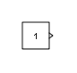

* Gain: The Gain block multiplies the input by a constant value.

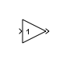

* Import and Outport block: Provide an input and output port for a subsystem or model.

**

* The degree to Radian block: Conversion from Degrees to Radians.

* Velocity Conversion block: Convert unit of the input signal to desired output unit.

* Sum block: Add or subtract inputs.

* Sin and cos block: Trigonometric and hyperbolic functions.

* Product block: Multiply or divide inputs.

* Vehicle Body 3DOF Dual Track: Implements a 3 DOF rigid two-axle vehicle body model to calculate longitudinal, lateral, and yaw motion. Accounts for body mass, aerodynamic drag, and weight distribution between the axles due to acceleration and steering.

* To Workspace block: Write input to specified time series, arrays, or structures in a workspace. For menu-based simulation, data is written in the MATLAB base workspace.

* Rolling Resistance Force Cal block:

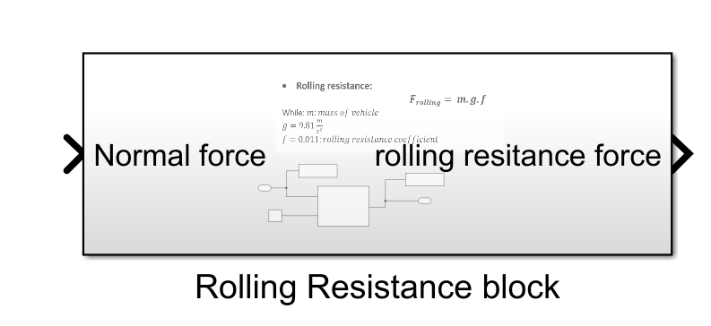

Based on equation (8), I can build the block to calculate the rolling resistance force of the vehicle. In this block, we will have the input port to provide the vehicle mass for the calculation and the output port to take out the rolling resistance force at the current driving state.

Modeling it into Matlab/Simulink:

* Normal and Longitudinal Force Cal block:

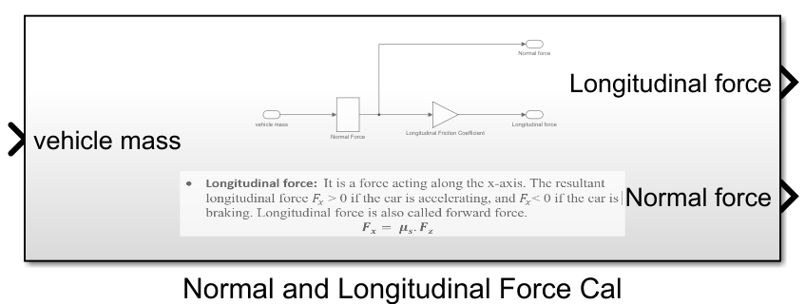

This block is used for normal force and longitudinal force, which is the outputs, calculation based on equations (1) and (5) by providing the vehicle mass as the input.

Modeling in Matlab/Simulink:

* Lateral Force Cal block:

In terms of lateral force calculation, there is the Lateral Force Cal block which mainly depends on the equations (2) and (11). In this block, the inputs are the steering angle left and right collab in collaboration with the vehicle speed and Cornering stiffness. From the input data, we can calculate the lateral force of the left and right wheels. Besides, we also can take out both wheel's sideslip angles for the other calculation.

Modeling into Matlab/Simulink:

* Wheel Alignment Input block:

This block is used for receiving the wheel alignment constants: Caster angle and Kingpin angle. Moreover, we can add with cos block, sine block, and tan block of Matlab/Simulink which is mentioned above to send the output as the sin Kingpin, cosine Kingpin, tan Kingpin, cosine Caster, sine Caster, and tan Caster.

* The Pneumatic Trail Cal block:

This block is going to be used to calculate the pneumatic trail of the wheels. In the Pneumatic trail input port, there is the longitudinal force signal, left and right sideslip signal, and Cornering stiffness signal.

From the above equation, we can model it into Matlab/Simulink:

* The Mechanical trail block:

This block will use the constant scrub radius and tire radius following the Michelin 175/65R14 as the inputs

And model in Matlab/Simulink:

* The Resistance Torque Calulation by Normal Force block:

This block is used for the resistance torque caused by the normal force $F_{z}$. From equation (9), these resistance components include wheel alignment in cosine, sine, and tan; the scrub radius and tire radius; left and right steer angle in sine and finally the normal force. From those input signals, this block can calculate the resistance moment of the left and right front wheels.

Modeling in Matlab/Simulink:

* The Resistance Torque by Longitudinal Force block:

This block is used for the resistance torque calculation caused by the longitudinal forces $F_{X}$. Based on equation (5), this block needs many input parameters including the sine and cosine of wheel alignment (Kingpin and Caster angle), longitudinal force, rolling resistance force, left and right lateral force, tire radius, and scrub radius, sine and cosine of left and right steer angle. All parameters are mentioned in the previous subsystems. By using specific factors, the resistance torque or moment is caused by longitudinal forces of the left and right wheel.

Modeling into Matlab/Simulink:

* The Total Resistance Torque by Lateral Force FY block:

This block is used for the resistance torque calculation caused by the lateral forces $F_{Y}$. Based on equation (5), this block needs many input parameters including the sine and cosine of wheel alignment (Kingpin and Caster angle), longitudinal force, rolling resistance force, left and right lateral force, tire radius, and scrub radius, sine and cosine of left and right steer angle, left and right pneumatic trail, mechanical trail. All parameters are mentioned in the previous subsystems. By using specific factors, the resistance torque or moment is caused by lateral forces of the left and right wheels.

Modeling into Matlab/Simulink:

* From all the blocks mentioned above, we can model the total resistance torque of both front wheels $M_{z}$ into by using equation (10):

Finally, the total resistance torque block can be created as:

with the operation flow as:

Generally, this block will take the inputs such as Kingpin angle, Caster angle, Camber angle, vehicle speed, vehicle mass, and left and right steer angle to calculate the final resistance torque at different driving situations.

# V/ RESULT AND DISCUSSION:

* *The result will be calculated from the mean value of the resistance moment of two front tyres of VIOS.*

All the parameters[1] will be taken from the table below:

**Table 2 –** Model Parameters.

|  |  |  |
| --- | --- | --- |
| **Symbols** | **Value** | **Name** |
| $$t_{p0}$$ | 0.03 [m] | Pneumatic trail at zero slip angle |
| g | 9.81 [m/ $s^{2}$] | Gravity of earth |
| $$τ$$ | [rad] | Caster angle |
| $$f$$ | 0.011 | Rolling resistance coefficient |
| $$γ$$ | [rad] | Kingpin angle |
| $$ε$$ | [rad] | Camber angle |
| $$C_{ε}$$ | N/rad | Camber stiffness of tire |
| $$C_{α}$$ | N/rad | Cornering stiffness of tire |
| $$μ_{s}$$ | 0.35 | Friction coefficient |
| $$R_{nom}$$ | [m] | Nominal radius of tire |
| $$l$$ | [m] | Wheelbase |
| $a_{2}$ | [m] | Distance from the center of vehicle to rear axle |
| $$α_{f}$$ | [rad] | Front side slip angle |
| $$t_{p}$$ | [m] | Pneumatic trail |
| $$t_{p}$$ | [m] | Mechanical trail |
| $$t$$ | [m] | Total trail |
| $$r_{kp}$$ | [m] | Scrub radius |
| $$δ$$ | [rad] | Wheel steer angle |
| $$F_{x}$$ | [N] | Longitudinal force |
| $$F_{y}$$ | [N] | Lateral force |
| $$F_{rolling}$$ | [N] | Rolling resistance force |
| $$F_{z}$$ | [N] | Normal force |

After completely build the mathematical model to calculate the total resistance torque, this section is going to show all the investigations about how wheel alignment and relevant factors can affect the value of resistance torque:

* **The vehicle speed affects the resistance torque:**

**Figure 17: The vehicle speed effect on the total resistance torque**

As shown in Figure 17, we investigate the total resistance force while steering with a steering force of 20 N.m, a vehicle weight of 550kg, and wheel angles of Kingpin = 9 degrees, Caster = 5 degrees, and Camber = 0 degrees. In the investigation, we will consider how the total resistance torque will be affected by changing the vehicle speed (in the range of 5 km/h to 30 km/h). It is obvious that the value of the resistance torque at each level of vehicle speed is different when the driver provides the steering wheel torque. At the lowest vehicle speed, the total torque created is from 100 N.m to approximately 170 N.m, which is the biggest value. In the same condition, this value is approximately 160 N.m, 160 N.m, and over 160 N.m corresponding to 10 km/h, 20 km/h, and 30 km/h respectively. This means that at higher vehicle velocity, the total torque that resists the steering effort of the driver is a little smaller. To test the accuracy of the model, I will take the comparison with the real test model in the article “*Study on Low-Speed Steering Resistance Torque of Vehicles Considering Friction between Tire and Pavement*”.

**Figure 18: The tested model in the article**

In the article model, the total resistance torque was investigated when the vehicle speed is from 0 to 20 km/h and the steering wheel angle is from 0 to 600 degrees. We can see that the total resistance torque is higher when the vehicle is lower in the article model and this value has the similarity with the results from my model in the acceptable error. That is the reason why I can say that my model is valid.

* **The steering wheel angle affects the resistance torque:**

**Figure 19: The steering wheel angle effects on the total resistance torque**

In Figure 17, we set the input torque for the driver from 0 N.m to 25 N.m in 25 seconds which means the vehicle is going to turn left in the model. After 25 seconds, we set up the input torque as 0 N.m which means the driver does not provide the steering torque anymore. It is obvious that when the driver applies the steering torque, the vehicle keeps turning left and the steering wheel angle also increased corresponding to the driver's steering torque. Otherwise, when there is no steering torque, the steering wheel angle becomes gradually lower. The reason for this problem is the total steering resistance torque will align the vehicle direction that turns the steering wheel back to the original position and no steering angle anymore as the next figure illustrates.

**Figure 20: The time responses of the steering angle of the front wheel**

Figure 20 illustrates the steering angle of the front wheel in the time responses. It is very clear that the steering angle is going to be smaller gradually when the driver does not apply the steering torque after 25 seconds. The reason is the total resistance torque will align the driving wheel to make the vehicle moves straight.

* **Vehicle mass effects on the total resistance torque:**

**Figure 21: Vehicle mass effects on the total resistance torque**

In this section, the vehicle mass effects on the self-resistance torque are going to be surveyed among different vehicle mass levels: from 550kg to 750kg when the other factor was constant. From the given data, we can observe that the total resistance torque is increasing proportionally at constant steering torque, vehicle speed, and wheel alignment. This is expected, as a heavier vehicle would experience more resistance and the reason is when the vehicle mass changes it will cause the change in the moment components such as the resistance torque caused by longitudinal forces, resistance torque caused by lateral forces, and even the resistance torque caused by the normal force. In conclusion, if there are more passengers or luggage in the vehicle, the driver would have to apply more effort to steer the vehicle.

* **Wheel alignment impacts the steering resistance torque:**

In the previous cases, we tested and surveyed how vehicle mass and vehicle velocity can affect the total resistance moment and there are two opposite trends when we increase both. In this section, we are going to investigate the effect of the wheel alignment: Kingpin angle, Camber angle, and Caster angle on the steering resistance torque.

* Kingpin angle:

**Figure 22: Kingpin angle impact on the total resistance torque**

This figure illustrates how the Kingpin angle can affect the resistance moment. In this investigation, the kingpin angle will be changed from 0 degrees to 8 degrees (Kingpin angle value of VIOS). It is obvious that when we change the value of this angle, the resistance torque also increases. The value of the torque for 0 degrees in Kingpin and 8 degrees in Kingpin is approximately 20 N.m to over 50 N.m at 540 degrees of the steering wheel angle and approximately 80 N.m to 130 N.m at 540 degrees of the steering wheel angle. This value changes rapidly when we increase the Kingpin angle.

* Caster angle

**Figure 23: Caster angle effects on the steering resistance torque**

In comparison with the Kingpin angle, the Caster angle effects have a similarity with the Kingpin angle effects which means when we increase the Caster angle, the value of total resistance torque also increases. However, the Caster angle’s increased torque value rate is smaller than the Kingpin’s angle increased torque value.

* Camber angle:

**Figure 24: The Camber angle effect on the total resistance torque**

The Camber angle also has an impact on the total resistance torque as Figure 24 illustrates. In this investigation, the value of the torque will be calculated by changing the Camber from -2 degrees to 2 degrees to see how this angle affects the resistance torque. Through this survey, we can figure out that the total resistance torque is much higher when the Camber is negative (in this case the vehicle is taking a left turn). That means if the Camber is smaller than zero, the driver must apply much more effort to control the vehicle when taking a turn. And this value is going to decrease if we set the positive Camber angle (from over 110 N.m to approximately 40 N.m at 0 degrees steering wheel angle).

# VI/ CONCLUSION AND FUTURE PLAN:

All the steering resistance torque surveys are clearly mentioned in this Capstone project. Moreover, a total steering resistance torque model of a power steering system is built exactly by applying the above knowledge: numerical equations and relevant factors. It can also be used for the design of other power steering systems, thanks to the resistance torque model to calculate the appropriate assist torque in different driving conditions.

The main conclusion obtained in this Capstone project is how the wheel alignment especially the Caster angle, Kingpin angle, and Camber angle affects the resistance moment in collaboration with specific factors such as vehicle mass, vehicle velocity,… Through all the figures mentioned above, we can conclude that wheel alignment has a huge impact on the total steering resistance torque in collaboration with vehicle mass and vehicle speed.

In the future, it is recommended to develop to provide the exact results in comparison with reality in more different driving situations.

# VII/ REFERENCES:

1. Jazar, R. N. (2017). *Vehicle Dynamics: Theory and Application* (3rd ed. 2017). Springer.
2. Lenzo, B. (2021). *Vehicle Dynamics: Fundamentals and Ultimate Trends (CISM International Centre for Mechanical Sciences, 603)* (1st ed. 2022). Springer.
3. Cossalter, V. (2006). *Motorcycle Dynamics* (2nd ed.). Lulu.com.
4. Reimpell, J., Stoll, H., Betzler, J. W., & Engineers, S. O. A. (2022). *The Automotive Chassis: Engineering Principles* (2nd ed.). Society of Automotive Engineers.
5. American Association of State Highway and Transportation Officials. (2022). *A Policy on Geometric Design of Highways and Streets 2011* (6th ed.). Amer Assn of State Hwy.
6. Wikipedia contributors. (2022, September 13). *Vehicle dynamics*. Wikipedia. https://en.wikipedia.org/wiki/Vehicle_dynamics
7. Pauwelussen, J. (2014). *Essentials of Vehicle Dynamics* (1st ed.). Butterworth-Heinemann.

Hu, C. H. (2008). Modeling and Simulation of Automotive Electric Power Steering System. *2008 Second International Symposium on Intelligent Information Technology Application*. https://doi.org/10.1109/iita.2008.51

1. *[(The Automotive Chassis: Engineering Principles)] [Author: Jörnsen Reimpell] published on (January 2004)*. (n.d.).
2. Halderman, J. (2016). *Automotive Chassis Systems (Halderman Automotive Series)* (7th ed.). Pearson.
3. Cao, D., Tang, B., Jiang, H., Yin, C., Zhang, D., & Huang, Y. (2019). Study on low-speed steering resistance torque of vehicles considering friction between tire and pavement. *Applied Sciences*, *9*(5), 1015. https://doi.org/10.3390/app9051015
4. Gao, Z., Wang, J., & Wang, D. (2011). Dynamic Modeling and steering performance analysis of active front steering system. *Procedia Engineering*, *15*, 1030–1035. https://doi.org/10.1016/j.proeng.2011.08.190
5. Gillespie, T. D., Duprey, B. L., Sandu, C., & Taheri, S. (2021). *Fundamentals of Vehicle Dynamics*. SAE International.

1. Jazar, R. N. (2017). *Vehicle Dynamics: Theory and Application* (3rd ed. 2017). Springer.